|  |  |
| --- | --- |
| **Ex. No. 4** | **Design a Sign-In and Sign-Up Page with Navigation Bar using CSS** |
| **Date of Exercise** | **02.08.23** |

**Aim**

To create a sign-in and sing-up page with navigation bar using CSS.

**Description**

* There are two ways to create a horizontal navigation bar. Using inline or floating list items.
* display: inline; - By default, <li> elements are block elements. Here, we remove the line breaks before and after each list item, to display them on one line
* float: left; - Use float to get block elements to float next to each other
* display: block; - Allows us to specify padding (and height, width, margins, etc. if you want)
* padding: 8px; - Specify some padding between each <a> element, to make them look good
* background-color: #dddddd; - Add a gray background-color to each <a> element
* The display property specifies if/how an element is displayed.
* Every HTML element has a default display value depending on what type of element it is. The default display value for most elements is block or inline
* A block-level element always starts on a new line and takes up the full width available (stretches out to the left and right as far as it can).’=
* An inline element does not start on a new line and only takes up as much width as necessary.
* Compared to display: block, the major difference is that display: inline-block does not add a line-break after the element, so the element can sit next to other elements.

**Program**

<!DOCTYPE html>

<html lang="en">

<head>

<meta charset="UTF-8">

<meta name="viewport" content="width=device-width, initial-scale=1.0">

<title>Sign up</title>

<style>

*{

margin:0px;

}

ul{

list-style-type: none;

background-color:lightblue;

padding:0px;

overflow:hidden;

}

li{

float:left;

width:20%;

text-align:center;

font-size:xx-large;

}

li a{

display:block;

text-decoration: none;

text-align: center;

}

li a:hover{

background-color: blue;

color:white;

}

.signin{

width: 35%;

height: 26%;

text-align:center;

border:1px solid black;

border-radius:6%;

background-color: pink;

}

.signup{

height: 40%;

width: 35%;

background-color:antiquewhite ;

border-radius: 6%;

padding-top: 5%;

}

.signin,.signup{

float: left;

margin-top: 10%;

margin-left: 11.5%;

text-align: center;

}

html,body {

height:100%;

}

.banner{

background-image: url(css.jpg);

background-color: blue;

background-repeat: no repeat;

background-size:cover;

height:100%;

}

h3{

padding-bottom: 2%;

text-align: center;

font-size: larger;

font-weight: bolder;

color:antiquewhite;

}

</style>

</head>

<body>

<ul>

<li><a href ="#home">Home</a></li>

<li><a href = "#products">Products</a></li>

<li><a href = "#Services">Services</a></li>

<li><a href = "#Contact">Contact</a></li>

<li><a href = "#Software">Software</a></li>

</ul>

<div class="banner">

<div class="signin">

<form action ="" method = "post">

<h3 align = "center">Sign In</h3>

<label for = "name">User Name</label>

<input type = "text" id = "name" name = "user" required placeholder="Enter Name"><br><br>

<label for="pass">Password</label>

<input type = "password" name = "pass" pattern="(?=*/d)(?=*[a-z])(?=,*[A-Z],{8,} )"required placeholder="Enter Password"><br><br>

<input type = "submit" onclick = "alert('submit')" value = "submit">

</form>

</div>

<div class="signup">

<form action="" method="post">

<h3>Sign Up</h3>

<label for = "name">User Name</label>

<input type = "text" id = "name" name = "user" required placeholder="Enter Name"><br><br>

<label for = "name">Email </label>

<input type = "text" id = "email" name = "user" required placeholder="Enter Email"><br><br>

<label for="pass">Password</label>

<input type = "password" name = "pass" pattern="(?=*/d)(?=*[a-z])(?=,*[A-Z],{8,} )"required placeholder="Enter Password"><br><br>

<input type = "submit" onclick = "alert('submit')" value = "submit">

</form>

</div>

</div>

</body>

</html>

**Output**

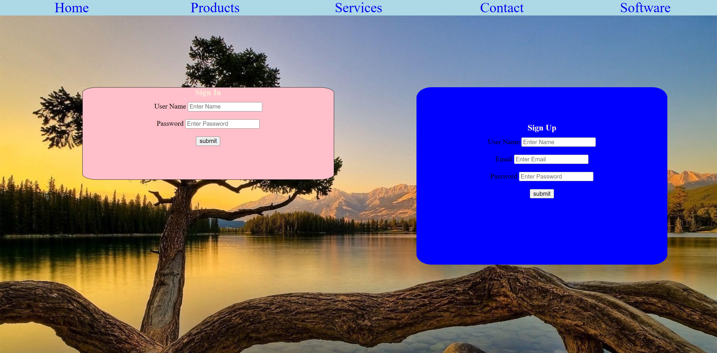

**Result**

The program is executed successfully and the program output is displayed in the web browser.­